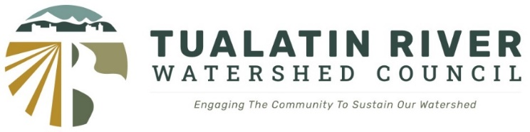

Draft Agenda

December 4, 2024
7:00 – 8:30 pm

- Meeting Called to Order – Rahim Harji
- Introductions
- Review and Approval of Agenda – Rahim Harji
- PRESENTATION: Tualatin Community Survey – Alexis Millett, Capacity Building Partnerships
The Tualatin Watershed Community Survey is a collaboration between the Tualatin Soil and Water Conservation District and Tualatin Riverkeepers. It was conducted by Capacity Building Partnerships. The intent of the survey was to survey a broad range of community members and organizational leaders to gain input and insights pertaining to how people are impacted by watershed issues as well as how they interact and access the watershed itself. The information will inform strategic planning processes for both organizations as well as be made available to other community partners who work in the watershed.

- Public Comment
- Approval of November 2024 Minutes
- Nomination of 2025 Slate of Officers
- Discussion Strategic Topics for 2025 Council Meetings
- Regional eDNA Information Sharing and Collaboration Workshop
  - When: January 8th – 12:00 to 4:00 pm
  - Where: Durham Wastewater Treatment Facility
16580 SW 85th Ave (16580 SW 85th Ave, Tigard, Oregon 97224)
  - Sponsored by the Tualatin River Watershed Council and Clean Water Services

- Adjourn

